# SECTION 5. MANAGEment PROCESS

## 5.1 Start-up

### 5.1.1 Estimation

**Functions:**

-Track purchases through payment reference number.

-Add products of the store to the website.

**Size Estimation:**

**Track purchases through payment reference number:**

The customer will enter the purchase reference number which is in the purchases table in the website’s database. A report including the item’s name, number and location (if it’s in the warehouse, the delivery company or on its way to the customer) will be viewed to the customer. Consequently, there will be access to two external databases, the warehouse and the delivery company. In the warehouse one table will be checked which is the dispatched items. In the delivery company’s table two tables will be checked which are the items received and items dispatched. A query will be used in order to connect between them and check at which stage the item is this query will have four outputs if it is dispatched from the warehouse or not, if it is received to the delivery company or not and if it is dispatched from the delivery company or not and therefore locates the place of the item.

**External input types(EI):** 1 input

**Record Types:** Purchases table

**Data Types:** Purchase reference number

**Complexity:** Low =3

**External output types(EO):** 1 report

**Record Types:** Purchases table, warehouse’s dispatched table, delivery company’s received table, delivery company’s dispatched table

**Data Types:** Item name, item number, location

**Complexity:** Average=5

**External inquiry types(EQ):** 1 query

**Record Types:** purchases (to get item number), dispatched(warehouse), dispatched (delivery company), received (delivery company)

**Data Types:** dispatched(warehouse), dispatched (delivery company), received (delivery company), location

**Complexity:** Average=4

**Logical internal filetypes(ILF):**1 internal database

**Record Types:** Purchases

**Data Types:** Item name, Item number

**Complexity:** Low=7

**External Interface Files(UI):** 2 databases (warehouse, delivery company)

**Record Types:** dispatched(warehouse), dispatched (delivery company), received (delivery company)

**Data Types:** location

**Complexity:** Low=5

**Total size=**(1x3) + (1x5) +(1x4) +(1x7) +(2x5) =29 FP x 60 =1740 LOC =1.74 KLOC

(MVC .NET http://www.qsm.com/resources/function-point-languages-table )

**Add products of the store to the website:**

The admin will receive a report from the warehouse of the available products getting their reference number, name and amounts, he will then add the items with their details to the to the internal database of the website as he will input the item name, amount and description.

**External input types(EI):** 3 inputs

**Record Types:** available products (website)

**Data Types:** name, amount, description

**Complexity:** Low=3

**External output types(EO):** 1 report

**Record Types:** available products(warehouse)

**Data Types:** reference number, name, amount

**Complexity:** Low=4

**External inquiry types(EQ):** none

**Record Types:** none

**Data Types:** none

**Complexity:** none

**Logical internal filetypes(ILF):** 1 internal database

**Record Types:** available products(website)

**Data Types:** name, amount, description

**Complexity:** Low=7

**External Interface Files(UI):** 1 external database(warehouse)

**Record Types:** available products(warehouse)

**Data Types:** reference number, item name, amount

**Complexity:** Low=5

**Total size=**(3x3) + (1x4)+(1x7)+(1x5)=25 FP x 60 =1500 LOC =1.5 KLOC

(MVC .NET http://www.qsm.com/resources/function-point-languages-table )

**Effort:**

**Track purchases through payment reference number:**

**Exponent Multipliers:**

**Product**

**RELY Required software reliability 1.00:** Nominal , because even though all databases should be regularly updated , there is a chance that the product is ahead with one step but the database was not yet updated by the warehouse or delivery company.

**DATA Database size 1.14:** High, information is being taken from more than one database external and internal.

**CPLX Product complexity 1.34:** Very High, this function is very complex as it will access three databases and a query in order to retrieve the final report to the customer.

**REUSE Required reusability 0.95:** Low, the function is less likely to be reused in other systems the same way because it will need a lot of modifications.

**Computer**

**TIME Execution time constraint 1.11:** High, a bit extra time might be needed in order to access all databases and execute the query in order to produce the final report.

**STOR Main storage constraint 1.00 :** Nominal, the internal database is relatively small as it will only contain the available products and purchases made.

**PVOL Platform volatility 1.30:** Very High , the database changes constantly.

**Personnel**

**ACAP Analyst capabilities 0.71:** Very High, the analyst is very efficient and cooperative.

**AEXP Application experience 0.81:** Very High, the team have worked on this type of projects many times.

**PCAP Programmer capabilities 0.76:** Very High, the team is very highly cooperative and have been working together on lots of projects before.

**PEXP Platform experience 0.91:** High,The developers have a high level of experience in the platforms they are using.

**LEXP Programming lang. experience 0.84:** Very High, programmers are specialized in MVC and have worked of many projects using it.

**PCON Personnel continuity 0.81:** Very High, the annual turnover is very low, almost no changes happen in employees

**Project**

**TOOL Use of software tools 0.78:** Very High, the latest Microsoft tools are being used which are highly integrated

**SITE Multisite development 0.93:** High, all the team members are located in the same site, but the developer might need to contact other developers who are responsible for the warehouse or delivery company .

**SCED Schedule pressure 1.14:** Low, the function is very complex and the schedule is quite compressed.

**Exponent driver ratings:**

**PREC 3.72:** Nominal, the function is a bit similar to other previously designed functions but it has some differences.

**FLEX 1.01**: Very high, the function is only developed in one way.

**RESL 1.41:** Very High, the function is known but many changes may occur due to external databases.

**TEAM 5.48:** very low, the team works together in the same room.

**PMAT 1.56:** Very High, the function is complex and many changes can occur in its development.

A=2.94

B=0.91

Size=**1.74 KLOC**

Sum of exponent driver ratings=3.72+1.01+1.41+5.48+1.56=**13.18**

Product of exponent multipliers= 1.00*1.14*1.34*0.95*1.11*1.00*1.30*0.71*0.81*0.76*0.91*0.84* 0.81*0.78*0.93*1.14 = **0.469**

Sf=B+0.01*∑ (exponent driver ratings) =0.91+0.01*13.18=**1.0418**

Effort (PM) = A (Size)^sf x (Product of exponent multipliers) = 2.94(1.74) ^1.0418*(0.469) = **2.455**

**Cost Estimation:**

Each developer takes 2000$ per project.

Computers cost 700$ per computer.

Projector price 1000$

Total Cost for this function= (2000*3)+(700*3)+(1000/2)=8600$

**Add products of the store to the website:**

**Exponent Multipliers:**

**Product**

**RELY Required software reliability 1.00:** Nominal, because even though all databases should be regularly updated, there is a small chance that some products are available in the warehouse but their database isn’t yet updated.

**DATA Database size 1.14:** High, lots of new items are added to the database.

**CPLX Product complexity 1.00:** Nominal, this function is not very complex as it will access only two databases one to directly retrieve information from and the other is to directly add information in.

**REUSE Required reusability 1.07:** High, the function can be reused, with slight modification needed in the database connections.

**Computer**

**TIME Execution time constraint 1.00:** Nominal, the report produce only needs to be retrieved form one database and the information is directly added to the internal database so the execution time is normal.

**STOR Main storage constraint 1.17:** Very High, the internal database for the add function is very high as new products needs to be constantly added to the database.

**PVOL Platform volatility 1.30:** Very High, the database changes constantly.

**Personnel**

**ACAP Analyst capabilities 0.71:** Very High, the analyst is very efficient and cooperative.

**AEXP Application experience 0.81:** Very High, the team have worked on this type of projects many times.

**PCAP Programmer capabilities 0.76:** Very High, the team is very highly cooperative and have been working together on lots of projects before.

**PEXP Platform experience 0.91:** High, the developers have a high level of experience in the platforms they are using.

**LEXP Programming lang. experience 0.84:** Very High, programmers are specialized in MVC and have worked of many projects using it.

**PCON Personnel continuity 0.81:** Very High, the annual turnover is very low, almost no changes happen in employees.

**Project**

**TOOL Use of software tools 0.78:** Very High, the latest Microsoft tools are being used which are highly integrated

**SITE Multisite development 1.00:** Nominal, all the team members are located in the same site so few non- face to face communication is needed just some phones or e-mails but extra communication might be needed to contact developers responsible for the warehouse.

**SCED Schedule pressure 1.00:** Nominal, the function is not very complex and the schedule is not pressured.

**Exponent driver ratings:**

**PREC** 4.96: Low, the function is very similar to other previously designed functions with very slight differences.

**FLEX** 1.01: very high, the function is only developed in one way.

**RESL** 5.65: Low, the function is known and really slight changes can be made to it.

**TEAM** 5.48: very low, the team works together in the same room.

**PMAT** 6.24: Low, the function is pretty organized with a clear path to be developed upon.

A=2.94

B=0.91

Size= 1.5 KLOC

Sum of exponent driver ratings= 4.96+1.01+5.65+5.48+6.24=**23.34**

Product of exponent multipliers= 1.00*1.14*1.00*1.07*1.00*1.17*1.30*0.71*0.81*0.76*0.91*0.84*0.81*0.78*1.00 *1.00= **0.392**

Sf=B+0.01*∑ (exponent driver ratings) = 0.91+0.01*23.34= **1.143**

Effort (PM) = A (Size)^sf x (Product of exponent multipliers) = 2.94(1.5) ^1.143*(0.392) =**1.832**

**Cost Estimation:**

Each developer takes 2000$ per project.

Computers cost 700$ per computer.

Projector price 1000$

Total Cost for this function= (2000*2)+(700*2)+(1000/2)=5900$

## 5.2 Work Planning

### 5.2.1 Work Activities

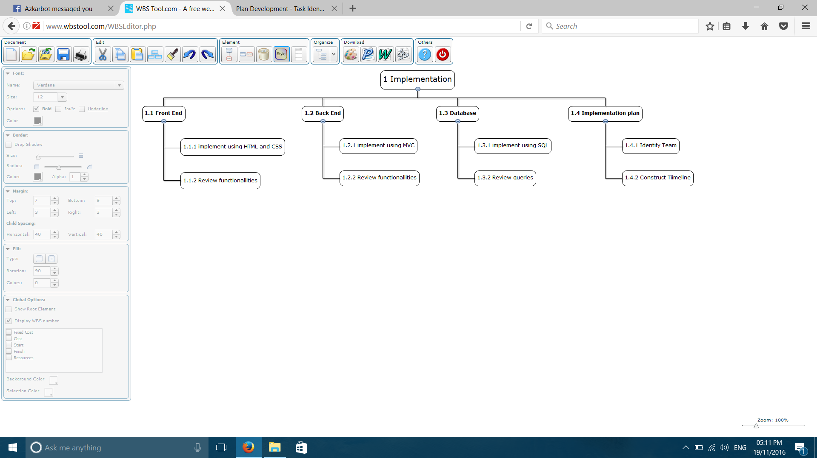

### 5.2.3 Resource Allocation

* 5 developers are need, two for the Add products of the store to the website function, and three for the Track purchases through payment reference number function as it is more complex.
* 5 computers are needed one for each developer.
* 1 meeting room with a projector is needed and shared between them.